Name: Mac Lawson
Date: Feb 23
08.07 Picture Lab Worksheet
Directions: Make note of your responses to the following questions as you work through the activities and exercise in the lesson.
Activity 5 Questions
QuestionYesNoIs the method getPixels2D in the Picture.java class?
XIs the method getPixels2D in the SimplePicture.java class?
XWill the following code compile?
DigitalPicture p = new DigitalPicture();
XAssuming a no-argument constructor exists for SimplePicture, will the following code compile?
DigitalPicture p = new SimplePicture();
XAssuming a no-argument constructor exists for Picture, will the following code compile?
DigitalPicture p = new Picture();
XAssuming a no-argument constructor exists for Picture, will the following code compile?
SimplePicture p = new Picture();
XAssuming a no-argument constructor exists for SimplePicture, will the following code compile?
Picture p = new SimplePicture();
X
Activity 5 Exercise Results

Describe your method for keepOnly red, blue, or green.
The keepOnlyBlue() method first calls this.getPixels2D() to obtain a 2D array of Pixel objects, which is then stored in the pixels variable. The method then proceeds to loop through each element of the pixels array using nested for loops.
For each Pixel object in the array, the method calls the setRed(0) and setGreen(0) methods on the Pixel object. This sets the red and green components of the pixel to 0, effectively removing any red and green color present in the pixel. As a result, only the blue component of the pixel remains, hence the method name skeepOnlyBlue".

For the negate method, paste your code related to calculating and setting the values for red, blue, and green.
public void negate()
{
Pixel[][] pixels = this.getPixels2D();
for (Pixel[] rowArray : pixels)
{
for (Pixel pixelObj : rowArray)
{
pixelObj.setRed(255 - pixelObj.getRed());
pixelObj.setGreen(255 - pixelObj.getGreen());
pixelObj.setBlue(255 - pixelObj.getBlue());
}
}
}
Paste a copy of the image that is the result of calling the grayscale.
For the method fixUnderwater, describe the algorithm you'd propose to accomplish the task.
The algorithm works by iterating through each pixel of the image, and for each pixel, it calculates the absolute difference between the pixel's red, green, and blue color components and the values (21, 163, 173), which are the reference color values for the underwater scene. The sum of these differences is stored in the "difference" variable. If the difference is greater than 21, it is considered to be a significant color cast and thus the pixel's color components are set to zero (black). This effectively removes the blue-green tint from the image.

Activity 6 Exercise Results
Paste the image that is the result of calling the method mirrorVerticalRightToLeft.
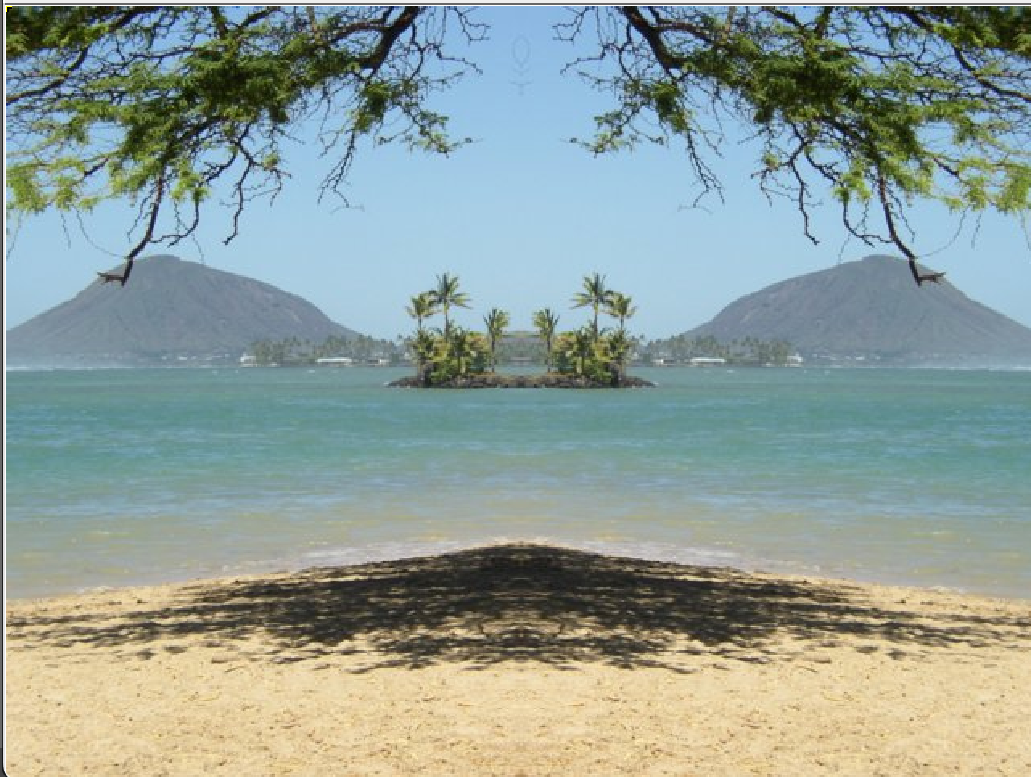
Describe the algorithm for the method mirrorHorizontal works.
This algorithm is a method for a class, which performs a horizontal mirror effect on an image represented as a 2D array of pixels.The method works by iterating through the top half of the image and swapping the color of each pixel in that row with the corresponding pixel in the bottom half of the image.

Paste the image that is the result of calling the method mirrorHorizontalBotToTop.
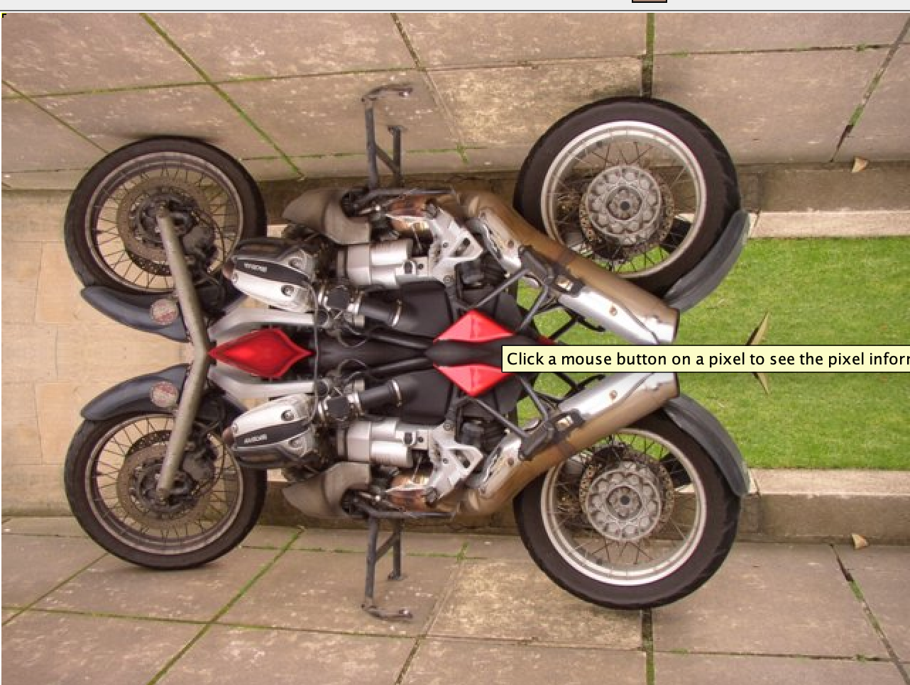
Activity 7 Questions
How many times would the body of this nested for loop execute? 90
for(int row = 7; row < 17; row++)
for(int col = 6; col < 15; col++)
How many times would the body of this nested for loop execute? 112
for(int row = 5; row <= 11; row++)
for(int col = 3; col <= 18; col++)

Activity 7 Exercise Results

What value is displayed for count after the nested loop ends in the mirrorTemple method? 18410
Paste the image that is the result of calling the method mirrorArms.
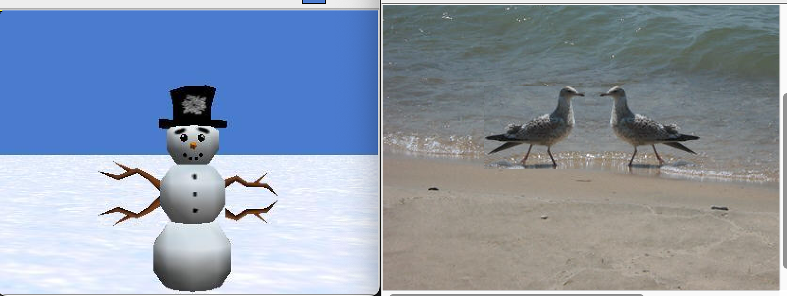
Paste the image that is the result of calling the method mirrorGull.

